./

Learning Report –CALCULATOR

Course Code: <CODE>



|  |  |  |  |  |  |
| --- | --- | --- | --- | --- | --- |
| **Ver. Rel. No.** | **Release Date** | **Prepared. By** | **Reviewed By** | **Approved By** | **Remarks/Revision Details** |
| 1. | 04/02/2021 | Mokshith B |  |  |  |
|  |  |  |  |  |  |
|  |  |  |  |  |  |
|  |  |  |  |  |  |
|  |  |  |  |  |  |

**Document History**

# 

Table of Contents

1. UML Diagram 4

**Factorial Operation** 4

**Prime Number** 5

**Find Prime Number** 6

# 1. UML Diagram

## **Factorial Operation**

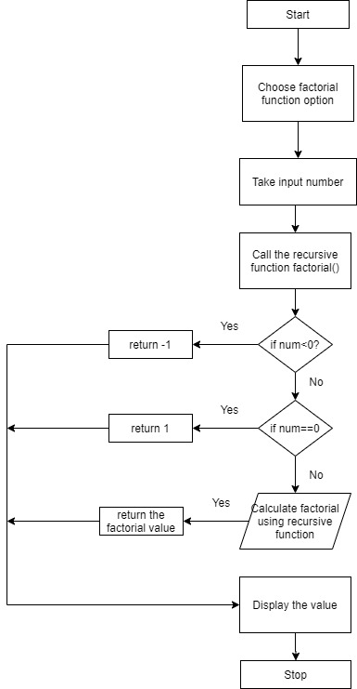

**Figure 1: Flow Chart to calculate Factorial of a Number**

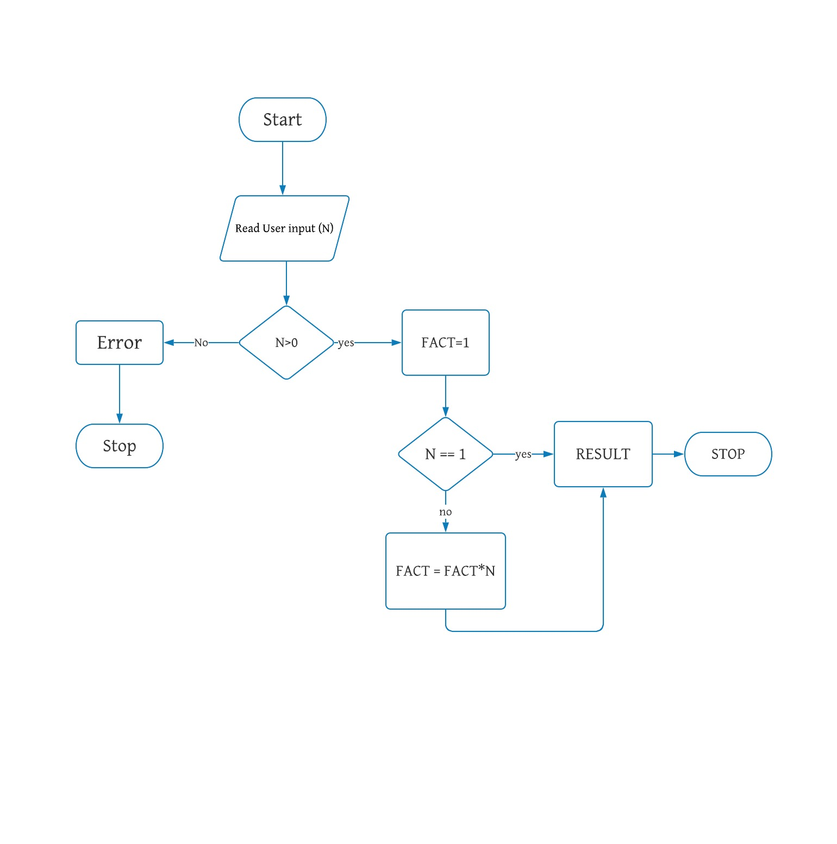

Figure 2: Flow Chart to calculate Factorial of a Number

## **Prime Number**

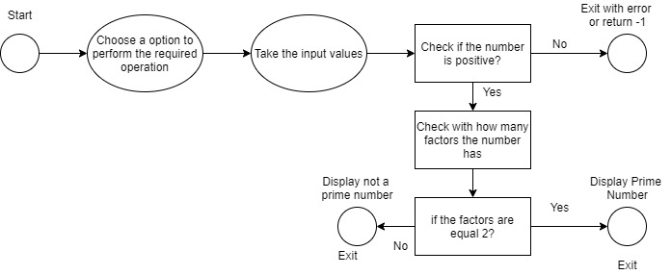

Figure 3: State diagram to find the prime number

## **Find Prime Number**

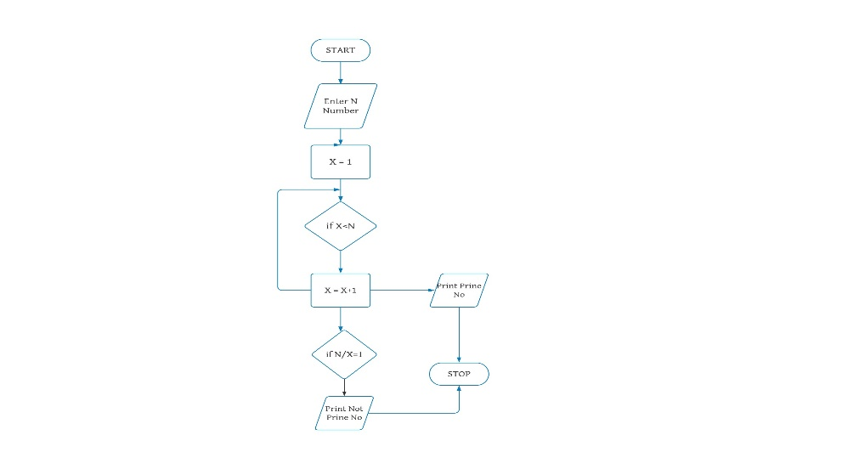

Figure 4: Flow chart to find Prime Number